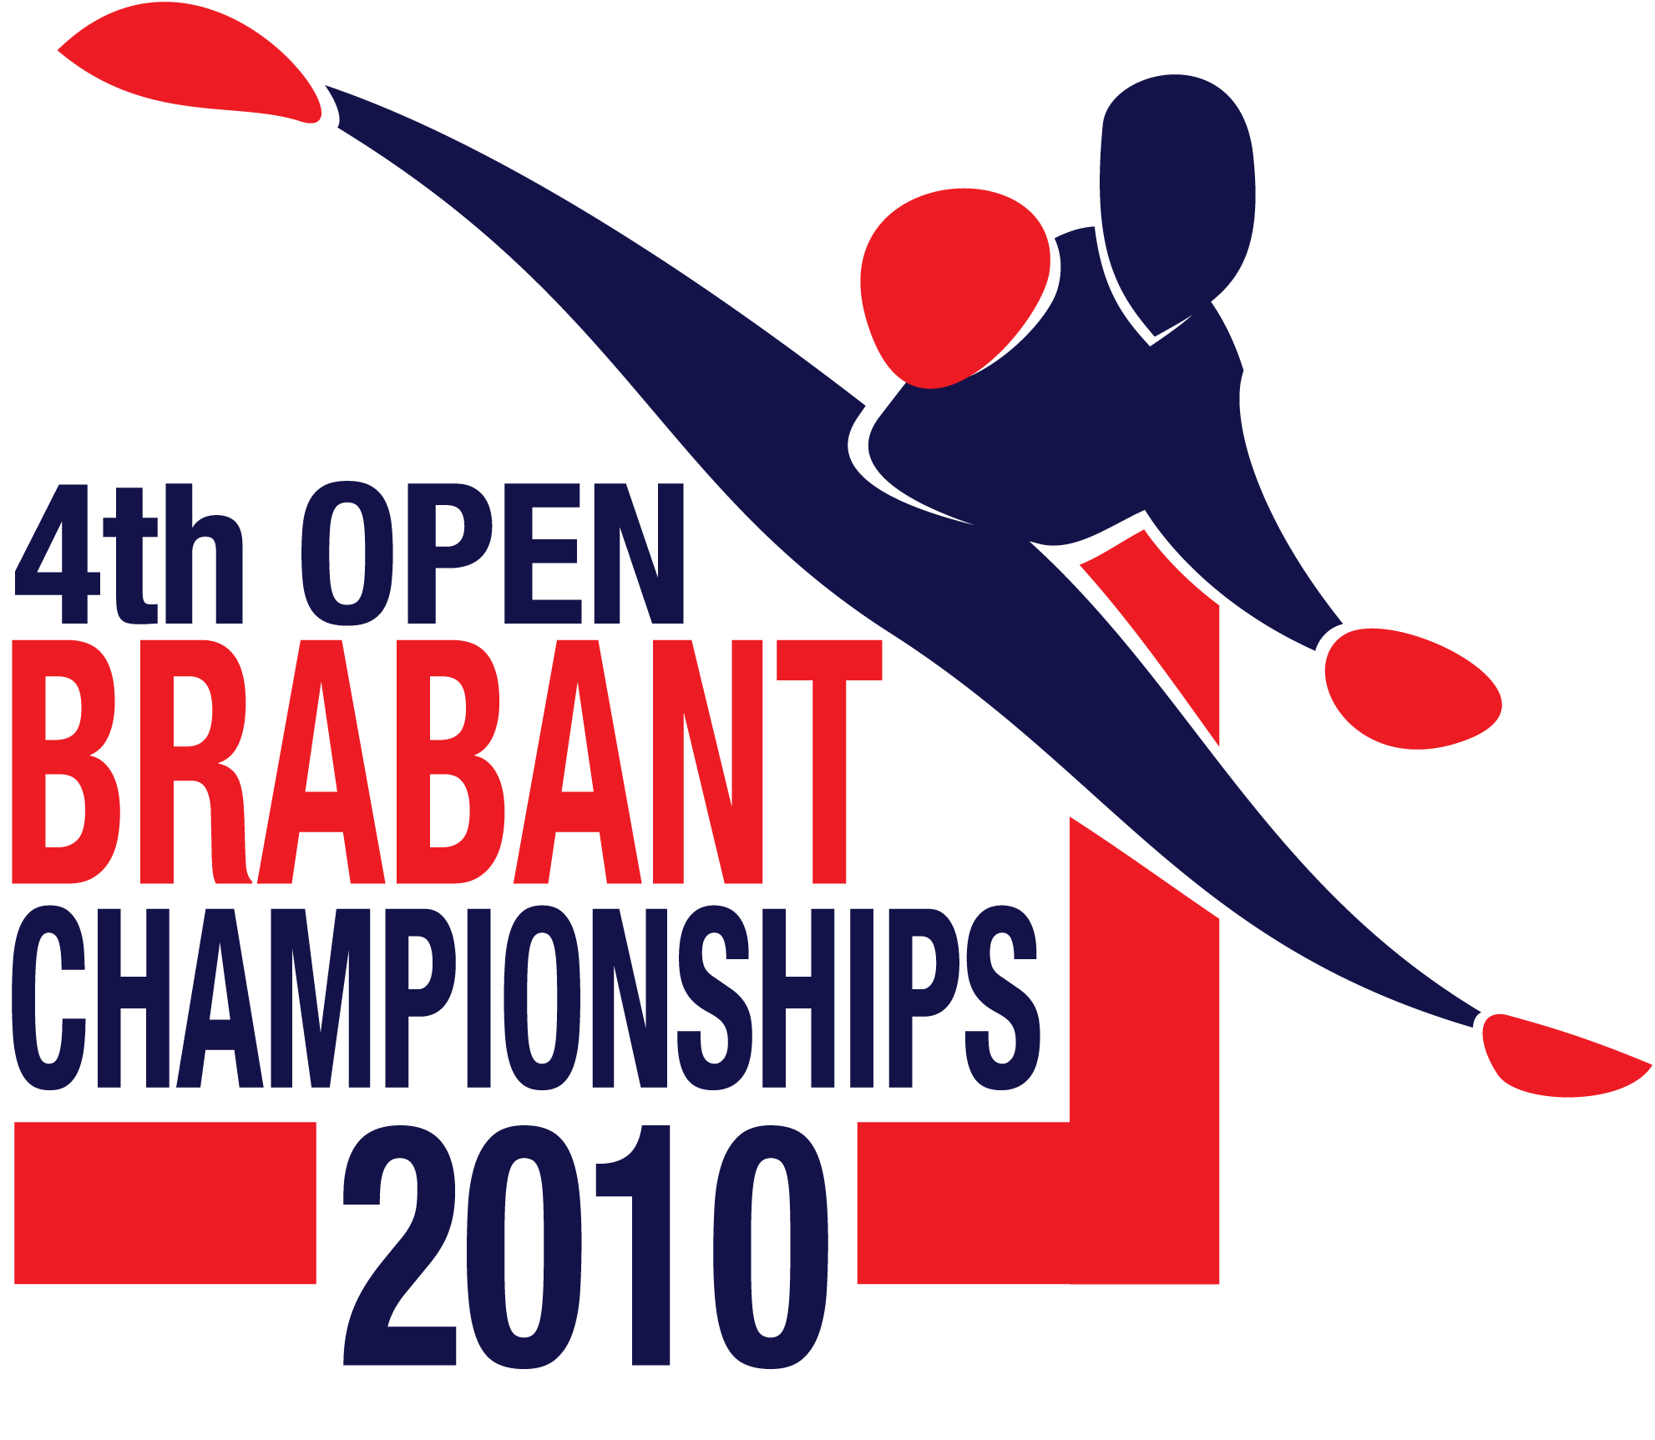



With support from Pro Martial Arts Tour
www.promatour.nl

4th Open Brabantse TKD Championships

February 7th 2010 te Heeze
Willy van de Mortel e-mail: willy.vandemortel@wxs.nl
Harry van Schaik e-mail: info@promatour.com
Master James Tjin-A-Ton e-mail: info@itf-taekwondo.nl

Date:
Sunday February 7th 2010

Place:
Sports hall De Pompenmaker, Ter Borchwardplein 32 Heeze, the Netherlands.

News!!
There is a agreement between the organisers from the 4th Open Brabant and
the 13th Open Slovenian.
On the 7th of February 2010 the 4th Open Brabant Championships in the south of the Netherlands and on the 27th of February the 13th Open Slovenian in Maribor.
This means that the winners in the A-class junior/senior on the Open Brabant Championships will get some support to compete also on the Open Slovenian.

Time table:
Hall open: 8.30 hour
Measuring / Weigth in 8.30-09.15 hour
Coach/Umpire meeting: 8.30 hour

Opening: 9.30 hour
Start Tuls 9.45 hour
Start Sparring around 11.30 hour
Pauze: 12.30 hour

Events and categories::
- Semi-contact individual sparring (I.T.F-Taekwon-Do rules);
Sparring Individueel: A / B klasse (kids/junior/senior)
B. Pool system sparring for junior/senior A classes with 10 competitors or less.
C. Tuls. (Individual with traditional pyramid system)

Sparring Time:
Kids: 1 x 1,5 minutes
Junior/Senior B classes: 1 x 2 minutes
Junior/Senior A classes: 1 x 2 minutes
Junior/Senior A classes 1 x 2 minutes (pool system)
(The organizer has the right to change the time)

Divisions and classes:
- There are divisions and classes for kids, juniors and seniors
- They are divided in grading, length and weights;
- Every event we use the knock-out system (1x 3e place.)
- Male/Female Kids/Juniors/Seniors are divided in separate classes.

Ages:
Kids Female: -14 year.
Kids Male: -14 year.
Junioren Female: 15 - 17 year.
Junioren Male: 15 - 17 year.
Senioren Female: 18 +
Senioren Male: 18 +

Classes Sparring:
A division: blue belt and higher (continue system)
B klasse: white up to green/blue belt (pointsysteem)

1. All competitors must have full insurance cover.
2. No boxing or open gloves allowed, shoft shin protectors are allowed, kids must wear
headquard during sparring!!.

Length Sparring:
Kids Female: -130, -140, -150, -160, -170, +170 cm.
Kids Male: -130, -140, -150, -160, -170, +170 cm.

Weight categorie Sparring:
Junior Female: -45, -50, -55, -60, +60kg
Junior Male: -52, -58, -63, -70, +70 kg
Senior Female: -52, -58, -63, -70, +70 kg
Senior Male: -54, -63, -71, -80, +80 kg

Changes to the categories can be made but will cost €10,- per change.
The organization reserves the right to put divisions together.

Tuls: 2 competitors against each other. Competitors perform 1 optional Tul.

1. White/White Yellow Belt: up to Dan-Gun
2. Yellow/Green/Green-Blue Belt up to Yul Gok
3. Blue/Red/Red-Black Belt: up to Choong-Moo
4. Black Belt I-degree up to Ge-Baek
5. Black Belt II-degree up to Juche
6. Black Belt III-degree up to Choi-Yong
7. Black belt IV-degree and up up to Moon-Moo

Divisions will be amalagated if there not enough competitors in a division.

Umpires: Must wear, blue/black trousers, white shirt long sleeves, blue/black tie.
Every club/team must bring umpires. If no umpire is submitted there will be a fine of €.75,- for every missing umpire.
Up to 7 competitors 1 Umpire
8 till 15 Competitors 2 Umpires
16 competitors ore more 3 Umpires

Coaches:
2 coach 1 up to 7 competitors
3 coaches 8 up to 14 competitors
4 coaches 15 up to 20 competitors
5 coaches 20 competitors or more

Rules:
Semi-contact individual points:
- 1 point for all hand techniques head/chest;
- 2 points for all kicks at the chest;
- 3 points for all kicks to the head.

Points, warnings, minus points and disqualification are recording
I.T.F.- AETF Taekwon-Do rules,
http://www.tkd-itf.home.pl/pub/ver_eng/comp_rules.html or
http://www.itfeurope.org/competition_rules.html
In case of a dispute the Head referee have the final decision.

Press:
No press allowed, pictures can be taken of the tribune that is very close to the arena’s.

Fees competition:
1 event 20.00 Euro
2 events 25.00 Euro

Entry forms send to:

Henny van Zon
Dommelseweg 87A
5554 NM Valkenswaard
Netherlands
Or to info@sportprijzenvalkenswaard.nl

The deadline for the entry form is Sunday January 24th 2010!!

Hotel accommodation:
We can offer different and very good accommodation.
Please inform us as soon as possible how many persons. See hotel form.
*There will be no transportation to the hotels or to the sport hall!!

Top event for competitors, coaches, referees and supporters:
The tournament directors can assure you that this event will satisfied your desire to compete in a professional environment. You and your athletes deserve this!!

Tournament Directors:
Master Willy van de Mortel,
Henny van Zon

Contact International:
Willy van de Mortel
Tel: +31-(0)492-663389
Mobile: +31-(0)6-21500360
E-mail: willyvandemortel@onsbrabantnet.nl

Contact National
Henny van Zon
Tel: 0031 40 2070920
Fax: 0031 40 20 709 30
Mobile: 0031 6 53 93 25 79
E-mail: info@sportprijzenvalkenswaard.nl

The Open Brabant Taekwon-Do is a Pro Leaque tournament, www.promatour.com

ROOM RESERVATIONS FORM
“4th Open Brabant Taekwon-Do 2010”
February 7th 2010 Heeze - Netherlands

€ 88,50 FOR A ROOM ON BASIS OF SINGLE USE
€ 92.50 FOR A SUPERIOR ROOM ON BASIS OF DOUBLE USE
€ 109,00 FOR A SUPERIOR ROOM ON BASIS OF TRIPLE USE *
- Rate is exclusive full breakfast cost € 13,50 per person
- Rate is exclusive tourist tax € 0,95 per person a night
- Rate is per room per night
- Rate is valid from Friday 5th February – Sunday 7th February 2010
- Rate is on the basis of availability

Company :_________________________________________________

Name Mrs. / Mr. :_________________________________________________

Address :_________________________________________________

__________________________________________________

Telephone number :_________________________________________________

Fax number :_________________________________________________

E-mail address :_________________________________________________

I would like to reserve ______ single standard room(s) /  double standard room(s)
❍ triple standard room(s) /  quad standard room(s)

I would to book breakfast:------------------------------- persons
I would like to reserve :  non-smoking room(s) /  smoking room(s)
Arrival date :_________________________________________________

Departure date :_________________________________________________

Number of nights :_________________________________________________

Guests name(s) :_________________________________________________

Credit Card nr. :_________________________________________________

Expiry date :_________________________________________________

Please send, e-mail or fax this form to :
Best Western Hotel Nobis

Nobisweg 1 , 5721 VA Asten
Direct telephone reservations → + 31 – 493-681300
Fax number → + 31 – 493-691058
E-mail address → info@nobis.nl
Website: → www.nobis.nl

